ZSight – Geolocation logic alignment and workflow



Document ID | DigDev_ZSight_Geolocation_Logic_FDD_v1.1
Product | Zsight
Environment | All
Confidentiality Level | Internal / Restricted

Contents
1 DOCUMENT INFORMATION 3
1.1 Validation 3
1.2 Document Distribution 3
1.3 Version Control 3
2 PREFACE 4
2.1 About this document 4
2.2 Related documents 4
2.3 Who should read this document 4
2.4 Terminology 4
2.5 Conventions Used 6
3 GEOLOCATION MODEL 7
3.1 Overview 7
3.2 Field Model 8
3.2.1 Reference point – the expectation 9
3.2.2 Container location – the observation 9
3.2.3 Resolving the reference point 10
3.2.4 Geofence 10
3.3 User Roles 10
4 SYSTEM LOGIC 12
4.1 Container Status Lifecycle 12
4.2 Device Report Evaluation 13
4.3 Notification Lifecycle 14
4.4 Null and Staleness Rules 15
5 WORKING PROCEDURES 16
5.1 Apply Manual Geolocation Override 16
5.1.1 Procedure 16
5.2 Archive a Container 17
5.2.1 Procedure 17
6 APPROVAL SIGNATURES 18

DOCUMENT INFORMATION

Validation
Name |  | Role | Date (dd/mm/aa)
Issued by | Oscar Rondon | Technical Writer | 14/08/2026
Verified by | Ezequiel Garcia | Developer | 18/08/2026
Approved by | Anthony Bures | Digital Development Manager | 18/08/2026

Document Distribution
Normal | Role
Oscar Rondon | Technical Writer
Anthony Bures | Digital Development Manager
Ezequiel Garcia | Developer

Version Control
Version | Date | Author | Description of changes
1.0 | 05/08/2026 | Oscar Rondon | 1st version of the functional design document for the geolocation logic workflow in ZSight.
1.1 | 14/08/2026 | Oscar Rondon | 2nd version of the functional design document for the geolocation logic workflow in ZSight – It includes changes on the diagrams and the override functionality.

PREFACE

About this document
This document defines the geolocation logic used by ZSight to determine where a monitored container is, to compare that position against where it is expected to be, and to raise a geofence violation when the two diverge by more than 150 m.
It exists to give development, QA, support and business stakeholders a single agreed description of that logic before further development continues.

Related documents
All documents or elements used for reference are presented in the following table:
Title | Reference | Author | Version
UGU | ZSight User Guide | Oscar Rondon | 1.0

Who should read this document
This document is written for readers who need to understand why ZSight reports a container's position as it does, rather than how to operate the interface.
- Developers and QA engineers implementing or testing geolocation behavior, particularly the reference selection and evaluation rules.
- Customer support and implementation specialists investigating geofence violations, distinguishing genuine relocation from GPS drift, and deciding whether a manual override or an archive is the correct response.
- Business stakeholders and product owners validating that the described logic matches intent before further development proceeds.
Readers who need to know how to navigate the application, locate a container, or read the notifications list should refer to the ZSight User Guide instead. Shared table behavior — filtering, searching, exporting and column selection — is documented once in the User Guide's Overall System Functionalities section and is not repeated here.

Terminology
Term Used | Description
Active Geofence Reference | Earlier term for the Reference Point, used in the geolocation specification. Retained here for cross-reference; the current model resolves the Reference Point from two values only.
Archive | The action that retires a container from operations and stops feed processing. Set in the Edit Container view with a reason. Existing geolocation data and notification history are retained.
Container | A monitored waste container. The record that geolocation fields belong to.
Container Location | The container's position on a given feed, referred to in development as Point B. Resolved by priority from Current, Estimated, Ref 2, Ref 1, and finally the device's last known coordinate. Always resolves to a value, so every feed carries a position.
Current | The most recent GPS position reported by the device. First in the priority order used to resolve the Container Location. Nullable, since a fix depends on satellite coverage.
Daily Feed | The record created from a single device report. A point-in-time snapshot of what one message carried.
DEMA | Double exponential moving average. The calculation used to derive Ref 2 from accumulated device fixes.
Device Report | An inbound message from a container’s device, received on the asset feed endpoint. May or may not carry a GPS fix.
Estimated | A container position received in the feed, used as the Container Location when no Current coordinate is present.
Evaluation radius | The 150 m radius drawn around the Reference Point. A container is in violation when its Container Location falls outside this radius. A fixed global value, not configurable per site.
Expectation | Where a container is understood to belong. Represented by the Reference Point.
Fix | A GPS position obtained by the device. Requires satellite coverage; its absence is normal operation rather than an error.
Geofence | The 150 m radius circle around the Reference Point that defines the acceptable area for a container. A container is compliant while its Container Location falls inside the geofence and in violation when it falls outside.
Geofence Reference | The group of stored reference points, Ref 0, Ref 1, Ref 2 and Manual Override, each preserved with its coordinate, source, created date and status.
Geofence Violation | The notification raised when the Container Location falls outside the 150 m geofence radius around the Reference Point.
GPS-stale review | A data-quality review raised when no valid fix has been received for a configured number of days. Suppresses movement alerts. Distinct from Device Offline, since a device without satellite coverage may still be reporting images and sensor data normally.
Last known coordinate | The device's most recently recorded position, retained between reports. Last in the priority order, and always available once a container has reported at least once.
Manual Geo Location | The override marker and its coordinates, set in the Edit Container view. Becomes the Reference Point only while its status is active.
Manual Override | An expected coordinate set explicitly by an authorized user, either by selecting a point on the map or by entering the values directly. Applied when its status is set to active, at which point the coordinates currently held in the latitude and longitude fields are committed. While active it outranks every system-generated reference and is never removed automatically.
Map Mode | The container details view that displays the geofence boundary as a circle around the active reference, with the container's assessed position marked separately.
Reference Point | The expected position a container is measured against, referred to in development as Point A. Resolved from two values only: the Manual Geo Location coordinates when the override status is active, otherwise the Site Location coordinates.
Ref 0 | The identifier shown in the geofence reference table for the Site Location. Belongs to the site record rather than to a container, so all containers at a site share the same value.
Ref 1 – Install Reference | A container position received in the feed, first available at installation. The first point at which the container's exact position is known. Contributes to the Container Location, not the Reference Point.
Ref 2 – Stabilized Device Reference | A DEMA-averaged container position received in the feed. Contributes to the Container Location, not the Reference Point.
Site | A customer location containing one or more containers. Supplies the service address from which Ref 0 is geocoded.
Site Location | Geocoded coordinates of the site service address, shown as Ref 0 in the geofence reference table. Belongs to the site record rather than to any individual container. Serves as the default Reference Point.
Work Order | The record grouping containers for an operational activity. Currently limited to the installation type.

Conventions Used
The following structures are used as recommendations.
Info: Supplementary Information

Tip: A recommendation or useful advice

Warning: A warning or important notice

Note: A notice.

GEOLOCATION MODEL

Overview
ZSight monitors waste containers fitted with cameras and IoT devices. Each device sends periodic reports containing container data and, when satellite coverage allows, a GPS position. Geolocation determines whether a container is within an acceptable distance of where it is expected to be. It does this by comparing two values on each device report:
Value | Definition | Derived From
Reference Point | Where the container is expected to be | The Site Location, or the Manual Geo Location when active
Container Location | Where the container is on this report | Coordinates received in the feed
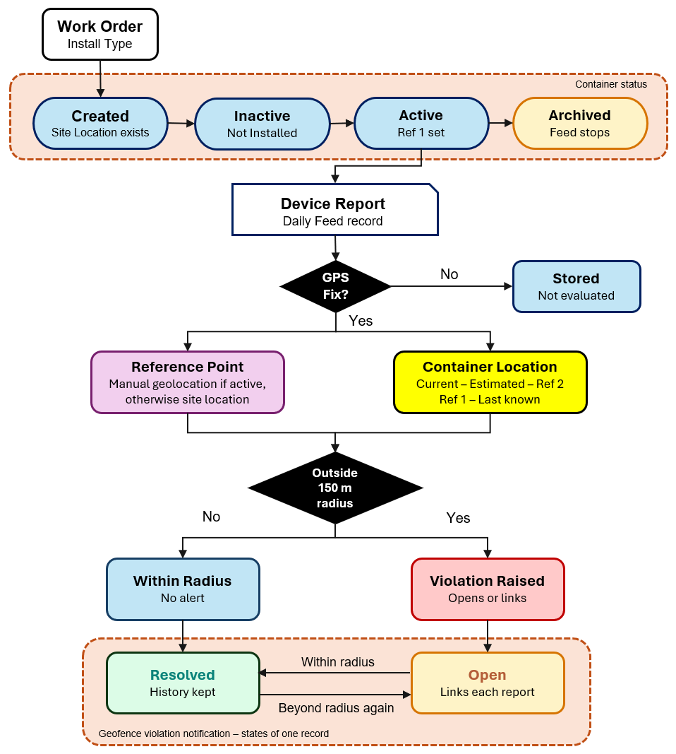
A geofence violation is raised when the distance between the two exceeds the 150 m evaluation radius.
The Reference Point resolves from two values only. By default it is the Site Location, the geocoded coordinates of the site service address. Because this is a physical address, it does not change. Where a user has set and activated a Manual Geo Location for a container, those coordinates are used instead.

The Container Location resolves from up to five values received in each feed, taken in priority order. Because the last of these is the device's last known coordinate, every feed produces a container position even when no new fix arrived. This is why the Container Location moves between reports while the Site Location does not.
The Site Location is geocoded from a street address, which on a large site may sit some distance from where containers actually stand. Where a site occupies a full block, the geocoded point can land at one corner, leaving containers at the far edges outside the 150 m radius despite being correctly placed. The Manual Geo Location exists to correct this, and is set independently for each container.
- Provisioning. A work order groups the containers to be deployed. Each container is created, registered, and remains inactive until a technician installs and activates the device on site.
- Reporting. Once active, the device sends reports. Each report is recorded as a Daily Feed entry.
- Evaluation. A report without a GPS fix updates nothing and raises no alert. Only a prolonged absence of fixes escalates, and it escalates to a data-quality review rather than a movement alert. A report with a fix updates the coordinates received from the device, after which the Container Location is resolved. The Reference Point is resolved in parallel.
- Outcome. The two values are compared against the 150 m evaluation radius. Within the radius, nothing is raised. Outside it, a geofence violation notification opens and remains open until a later evaluation falls back within the radius.
- Archiving. A container can be archived from any state, including before installation. Archiving stops feed processing.
Note: A Manual Geo Location changes where the system expects a container to be, and applies where the Site Location was never an accurate reference for that container. A container that has genuinely moved should be archived instead, since an override would conceal the movement rather than record it.

Field Model
Geolocation data is held in two groups. The Reference Point is the expectation (where the container should be). The Container Location is the observation (where it actually is). Each group resolves to a single value on every device report, and the distance between those two values is what produces or clears a geofence violation.
Group | Contains | Answers
Reference Point | Site Location (Ref 0), Manual Geo Location | Where the container is expected to be
Container Location | Current, Estimated, Ref 2, Ref 1, last known coordinate | Where the container is on this report

Both groups appear under Location & geofence on the container details page. The Reference Point sources are also shown on the Edit Container map, where they can be compared directly against the container's current position.
Note: Interface labels do not map one to one onto the field names defined in this section.

Reference point – the expectation
The Reference Point resolves from two values only.
Source | Used When | Can be absent
Manual Geo Location | The override status is active for that container | Yes
Site Location | No active override exists | No

- The Site Location is the geocoded coordinate of the site service address, and appears as Ref 0 in the geofence reference table. It belongs to the site record rather than to any individual container, so every container at a site shares the same value. This distinction matters. The Site Location identifies where the premises are, not where a container stands within them. In the same way that searching for a business by name returns the address of the building, not the position of anything behind it. It is created with the site record, before any container exists, and is held internally in ZSight until the container moves from Created to Inactive, at which point it is sent to the device provider. Because it represents a physical address, it does not change. Where a site occupies a full block, the geocoded point can land at one corner, leaving containers at the far edges outside the evaluation radius despite being correctly placed. The Manual Geo Location exists to correct this.
- A Manual Geo Location applies to one container only. Other containers at the same site are unaffected and are adjusted independently. Where no override has been saved, its coordinates default to the Site Location, and the two markers overlap on the map.
Info: A configurable evaluation radius per site was considered as an alternative and was not adopted. Per-container override was chosen instead, so that each container can be positioned individually rather than widening the radius for the whole site.

Container location – the observation
The Container Location is resolved from the coordinates received in each device report, taken in priority order. The first available value is used.
Priority | Source
1 | Current
2 | Estimated
3 | Ref 2 – stabilized, DEMA-averaged
4 | Ref 1 – install
5 | Device’s last known coordinate

Not every report carries every value. A report may contain several of these coordinates or only one. Because the device's last known coordinate is always available once a container has been reported at least once, every report still resolves to a container position.
This is why the Container Location marker moves between reports while the Site Location marker does not. Movement of a few meters between consecutive reports is expected and reflects normal GPS variation rather than physical relocation.
Ref 1 is the first point at which the container's exact position is known. Everything preceding installation describes the site, not the container.

Resolving the reference point
The Reference Point is resolved on every device report. Where the Manual Geo Location status is active, its coordinates are used. Otherwise, the Site Location coordinates are used.
Because the Site Location cannot be absent, the Reference Point always resolves to a value. There is no condition under which a container has no expected position.
Deactivating an override and saving returns the Reference Point to the Site Location on the next report. The override coordinates remain stored in the latitude and longitude fields but are not applied.

Geofence
The geofence is a 150 m radius centered on the Reference Point — the Site Location, or the Manual Geo Location when the override is active. A container is compliant while its Container Location falls at or inside that radius, and in violation when it falls outside.
- The radius is fixed at 150 m for all sites and is not configurable.
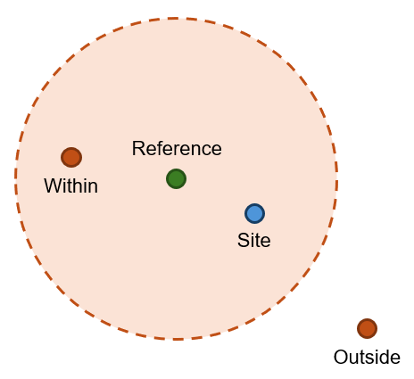
- The Edit Container map displays three markers:
Symbol | Key | Meaning
 | Manual geo location | The Reference Point while the override is active
 | Geofence | 150 m radius drawn around the Reference Point
 | Site location | Present but not used while the override is active
 | Container location | Resolved on each report

The figure shows a container with an active override. Where no override has been saved, the green and blue markers overlap, and the geofence is centered on the Site Location.
Container details display the current outcome as a Within Boundary indicator together with the measured distance from the Reference Point.
Note: The evaluation that applies the geofence, and the notification raised when a container falls outside it, are described in sections “Device Report Evaluation” and “Notification Lifecycle”.

User Roles
Most geolocation data is system-generated and requires no user action. Two operations are user-initiated, and both are performed in the Edit Container view.
Description | Standard User | Administrator
View container geolocation data on the container details page | 
View the geofence boundary and container position in Map Mode
View geofence violation notifications
Access the Edit Container view | Permission-based
Set or clear a manual geolocation override | Permission-based
Archive a container | Permission-based

Where a user does not have edit permission for a container, the edit icon is not displayed on the container details page, and the Edit Container view cannot be reached. Geolocation data remains visible in read-only form.
Warning: Edit permission has been observed to differ between accounts for the same signed-in user. Whether the permission is assigned globally or per customer account is unconfirmed.

SYSTEM LOGIC
This section describes the behavior of the geolocation feature: the states a container moves through, the evaluation performed on each device report, the lifecycle of the resulting notification, and the conditions under which evaluation is skipped or escalated. Diagrams in this section use three notations:
- State machines for lifecycles
- BPMN process for the runtime evaluation
- Decision table for the reference point rule

Container Status Lifecycle
The Status field on the container record has four values. The system sets them automatically, with the exception of archiving, which is a manual action. A container remains in each state until an event moves it.
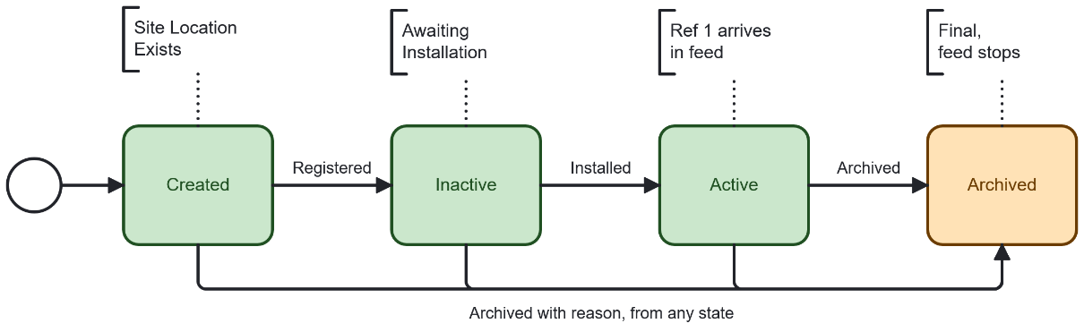
Status | Meaning | Set When | Geolocation data present
Created | Record exists and is being registered with the device provider. | Container record is created from a work order. | Site Location only (Ref 0)
Inactive | Awaiting physical installation. A device may be tentatively assigned, but the technician is not restricted to it. | Registration with the provider completes. | Site Location only (Ref 0)
Active | Installed and transmitted. Ref 1 arrives in the feed. | A technician installs and activates the device on site. | Site Location (Ref 0), Ref 1, and accumulating readings
Archived | Retired from operations. Feed processing stops. | A user archives the container and selects a reason. | Retained, no longer updated
The Site Location coordinates exist before the container record is created, as part of the site record. They are sent to the device provider at the transition from Created to Inactive.
Archiving is reachable from every state, including before installation. A container may be archived without ever having been installed — for example when the customer becomes inactive between provisioning and deployment.
Note: Container status is distinct from device status. A container in the Active state may still have a device that is offline or without satellite coverage. Device conditions are reported separately through the Notifications module.

Device Report Evaluation
This is the core runtime process. It is triggered by each device report received on the asset feed endpoint and always terminates in one of three outcomes: the report is stored without evaluation, the container is within the geofence, or a geofence violation is raised.
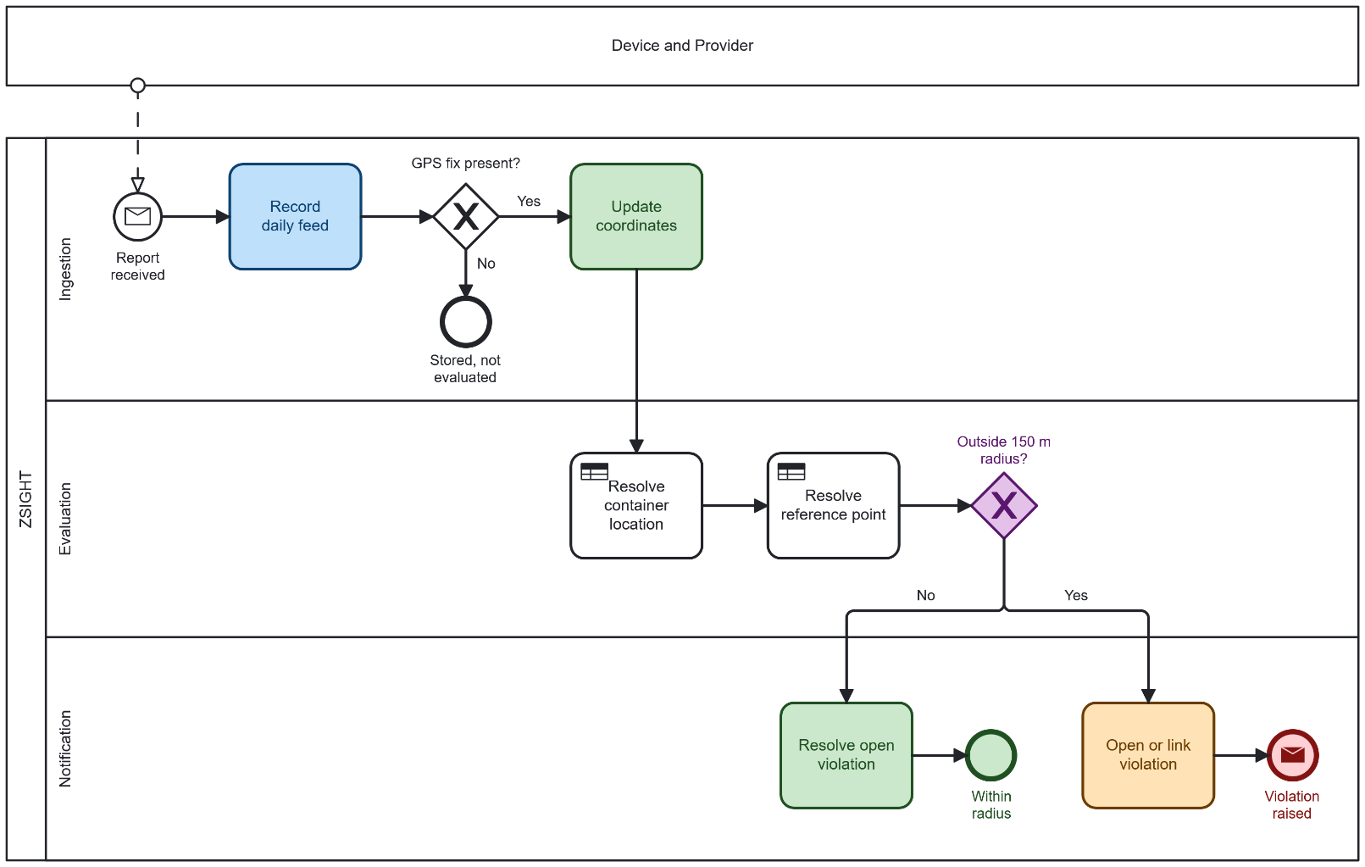
- Ingestion: Every report is recorded as a Daily Feed entry regardless of its contents. The process then checks whether the report carries a GPS fix. A report without a fix is normal operation, not an error. Satellite coverage is not always available, and many reports carry no position. When this occurs, the coordinates are left unchanged, the process ends, and no alert of any kind is raised. Prolonged absence of fixes is handled separately, see section 4.4.
- Evaluation: When a fix is present, the coordinates received in the report are updated. The process then resolves both sides of the comparison. The Container Location is taken from the coordinates carried in the report, in priority order:
Priority | Source
1 | Current
2 | Estimated
3 | Ref 2 – stabilized, DEMA-averaged
4 | Ref 1 – Install
5 | Device’s last known coordinate

The first available value is used. Because the last entry is available once a container has reported at least once, the Container Location is always resolved. In parallel, the Reference Point is resolved by the rule defined in section 3.2.3: the Manual Geo Location where its override status is active, otherwise the Site Location.
- Comparison: The distance between the Container Location and the Reference Point is measured against the 150 m geofence radius.
- Outcome: Inside the radius, any open violation for the container is resolved and the process ends. Outside the radius, a violation notification is opened, or the report is linked to an existing open notification.
Info: Movement of a few meters between consecutive reports is expected and reflects normal GPS variation rather than physical relocation. A container positioned near the edge of the geofence may therefore alternate between compliant and violating states across successive reports without having moved.

Notification Lifecycle
Raising a geofence violation is an event within the evaluation process. What happens afterwards is the notification moving between two states, driven by subsequent evaluations rather than by user action.
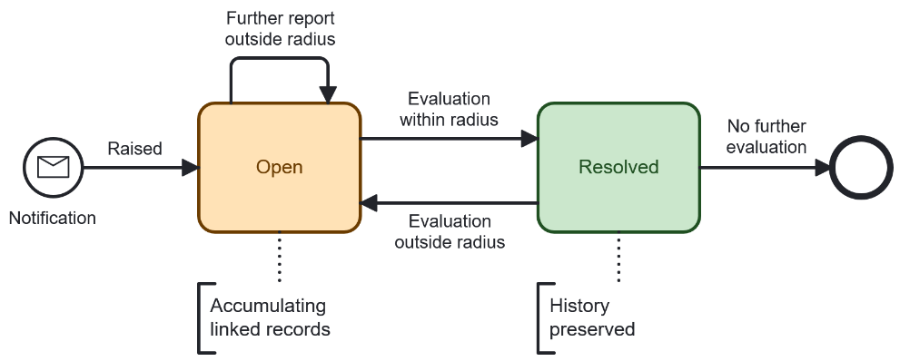
Status | Meaning
Open | The container has been measured outside the geofence and has not since returned inside it.
Resolved | A later evaluation fell inside the geofence. The record and its linked history are preserved; only the status changes.
Three behaviors follow from this model:
- Further violations do not create new notifications. While a notification is open, subsequent reports outside the radius link to the existing record rather than opening another. The first linked record carries the TRIGGER marker.
- Resolution is automatic. No user action closes a geofence violation. The status changes when a later evaluation falls inside the radius.
- Resolved is not terminal. A subsequent evaluation outside the radius reopens the same notification.
The distance can return inside the radius in two ways:
- The container physically returns, and the Container Location follows it on subsequent reports.
- An authorized user sets a Manual Geo Location and activates it, moving the Reference Point to the container's true position.
Note: A maximum of 20 linked feed records are displayed per notification. Remaining records are retained but not rendered. The selection currently shows the oldest records.

Null and Staleness Rules
These conditions determine when the evaluation described in section 4.2 is skipped or escalated to a data quality review rather than a movement alert.
Condition | System Behavior | Outcome
Report carries no GPS fix | Coordinates are not updated. Expected behavior, since a fix depends on satellite coverage. | No alert
No valid fix for the configured number of days | The container position is marked stale. Movement alerts are suppressed, since a stale position must not raise violations. | GPS-stale review

Because the Container Location falls back to the device's last known coordinate, a container that stops reporting fixes retains its last known position rather than losing one. This is why a prolonged absence of fixes escalates to a data quality review rather than a movement alert: the position is still present, but no longer current.
Info: A GPS-stale review is a data-quality condition, not a device failure. It is distinct from Device Offline — a device without satellite coverage may continue to report images and sensor data normally.

WORKING PROCEDURES
This section describes the two geolocation operations performed by users. Both are carried out in the Edit Container view and require edit permission for the container.

Apply Manual Geolocation Override
A Manual Geo Location sets an expected coordinate explicitly. While its status is active it becomes the Reference Point for that container, replacing the Site Location. It applies to one container only; other containers at the same site are unaffected.
The field is labelled Manual Geo Location in the Edit Container view and appears as Manual Override in the geofence reference table on the container details page.
- When to Use: The Site Location does not accurately represent where the container stands — typically on a large site where the geocoded address sits away from the container — and repeated false-positive geofence notifications are being raised as a result. The container's true position can be confirmed, for example through satellite imagery.
- When Not to Use: The container has genuinely moved. An override in that situation conceals the movement rather than recording it. Archive the container instead.

Procedure
- Open the container from the Containers module to display the container details page.
- Select Map Mode to view the container's position relative to its geofence.
- Select the edit icon, located to the left of the gallery and map mode icons.
- In the Edit Container view, scroll to the Manual Geo Location section.
- Set the coordinates by either method:
- Select Toggle Map to display the map, then select the point where the container is actually located. The Latitude and Longitude fields update to the selected position.
- Enter the values directly in the Latitude and Longitude fields.
- Set the Status toggle to active.
- Select Save.
Steps 5 and 6 can be completed in either order. The status toggle records that an override is active; it does not restrict when the coordinates can be set. Selecting Cancel at any point discards all changes, including any map selection already made.
Where no override has been saved, the Latitude and Longitude fields default to the Site Location coordinates, and the green Manual Geo Location marker overlaps the blue Site Location marker on the map.
The override remains active until a user sets the Status toggle back to inactive. It is never removed automatically. Setting the Status toggle to active applies whatever values are currently held in the Latitude and Longitude fields, verify the coordinates before activating. Deactivating the override and saving returns the Reference Point to the Site Location on the next report; the coordinates remain in the fields but are not applied.
Warning: This functionality is permission-based. Where the signed-in user does not have edit permission for the container, the edit icon is not displayed on the container details page and the Edit Container view cannot be reached.

Archive a Container
Archiving retires a container from operations and stops feed processing. It is the correct response to a container that is no longer at its recorded site.
- When to Use: The container has physically moved to a different location, has been removed from service, or the device has been lost or stolen.

Procedure
- Open the container from the Containers module to display the container details page.
- Select the edit icon, located to the left of the gallery and map mode icons.
- In the Edit Container view, scroll to the Archive section.
- Select a Reason from the list.
- Where Other is selected, enter the details in the field that appears.
- Set the Status toggle from Unarchived to Archived.
- Select Save.
Selecting Cancel at any point discards all changes.
Reason | Applies When
Container Change | The container is being replaced or exchanged at the same site.
Customer Inactive | The customer account is no longer active.
Temporary | The container is out of service for a limited period.
Permanent | The container is permanently removed from service.
Other | None of the above applies. A free-text details field is displayed for explanation.

Archiving does not delete anything. The container record, its geolocation data, its Daily Feed entries, and its notification history all remain accessible from the Containers module. What stops is forward processing: incoming reports are no longer evaluated, so no new feed entries are created and no geofence violations are raised.
Note: Both the Manual Geo Location and the archive action are set in the same Edit Container view and saved by the same Save button. Take care not to modify one while intending to change only the other.

APPROVAL SIGNATURES
Digital signature blocks below are formatted for DocuSign / Adobe Sign.
Name | Role | Digital Signature Block | Date (dd/mm/aa)
Approval’s name | Approval’s role |  | 05/08/2026

--- END OF THE DOCUMENT ---

